L05 Participation Assignment – functions

Background
Explore the use of fuctions.

Procedure
Answer the following questions with cut and paste or screenshots.

- Run the following code and paste the error code below.
a, b, c = 1, 2, 3, 4
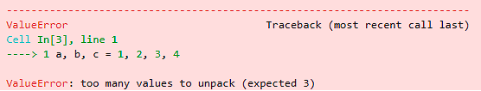

- A common way to unpack an iterable of values is to put the tuple of identifiers (a, b, c) on the left side of the assignment and an iterable of values on the right (1, 2, 3, 4). Based on the error in question one, change the code below to prevent errors and store all of the values.
Original code: a, b, c = 1, 2, 3, 4
Your code:

- Add the unpacking character to the print lines below to iterate through collections without displaying the enclosing braces. Paste your revised code and output below:
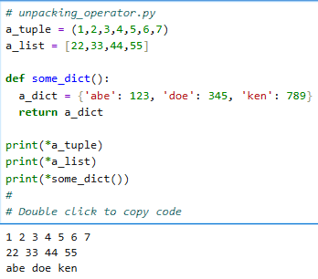

- Rewrite the following function as a lambda function. Show your code and output below:
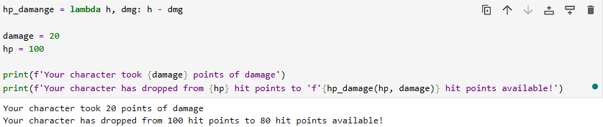

- Create a docstring for scoreToNumber function in the code below. Use a format similar to this to summarize the function, describe the parameters, data types, and returns. Show your code and output. 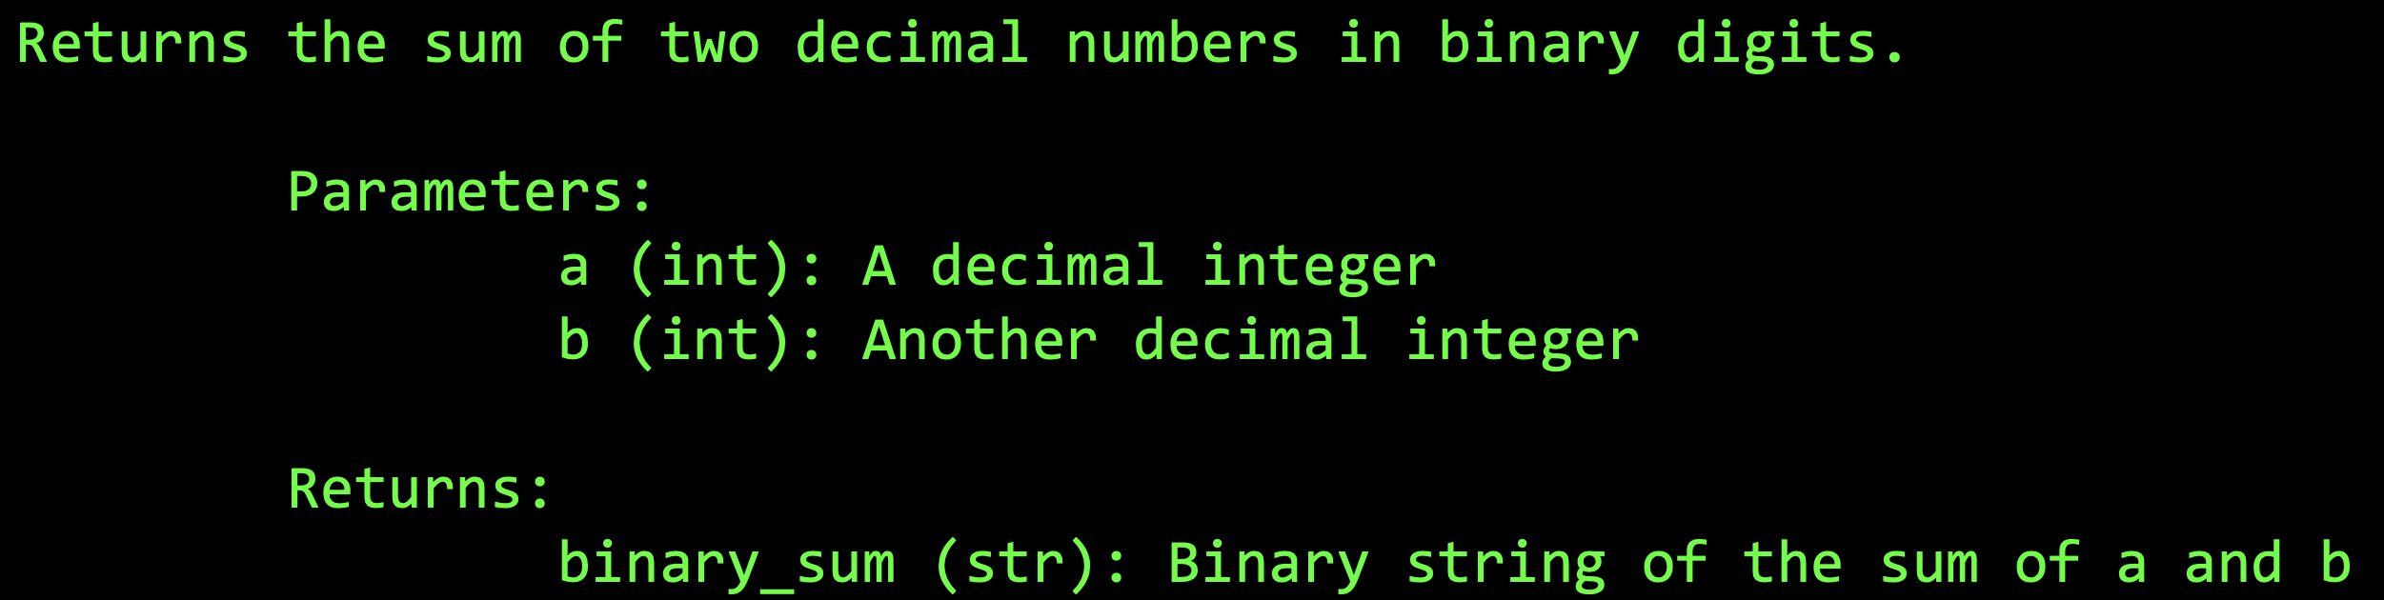
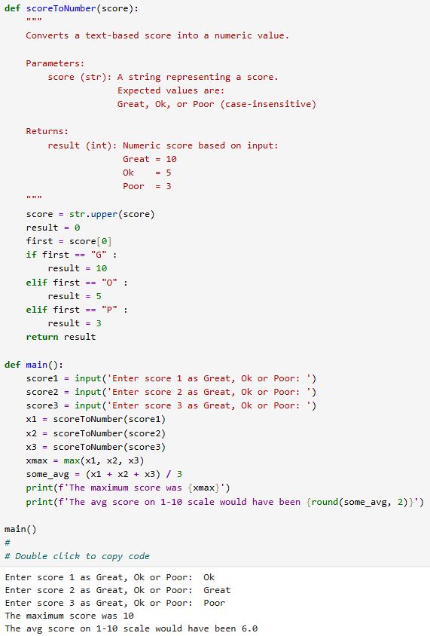

- Create mapped tuples of letter to numeric grades in the lambda function. Run the code and note the output of the lambda function.
- Wrap the lambda function with a list function
- Apply the unpack operator to the ‘a’ parameter in the lambda function.
In this context, it is being used as an ‘arbitrary qty of arguments’. Show your revised code and output. (Double-click code box below to access)
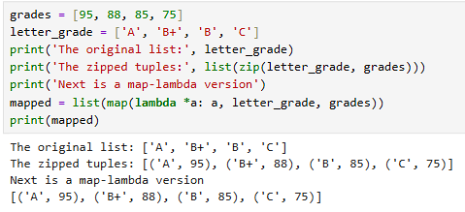

- Complete the following list comprehension to produce the result (in blue) in which x never creates a two-tuple with y if they are equivalent. Replace each underscore with the appropriate Python keyword. Show your revised code and output:
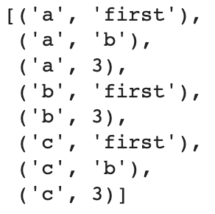
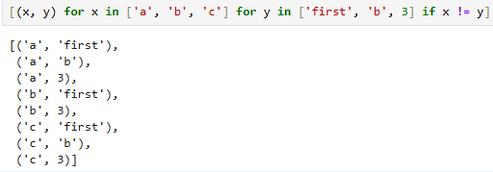

- Code golf is a type of recreational computer programming competition in which participants strive to achieve the shortest possible source code that solves a certain problem. The following code checks a listb for negative values. If a negative value is found, the function returns the positive value of the found number. Demonstrate the efficiency of Python by revising the 8 lines of code into two lines of code to produce the same results. Show your code and output.
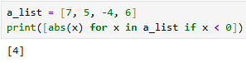

- Submit this word document to Canvas. Use copy and paste or screenshots for the answers. Questions should be included to use as a study guide.

